Experiment No. 2
Creating the Smart Contract
Atharva Prashant Pawar - (9427) [Batch - D]
Aim: Creating and deploying Smart Contract using Solidity and Remix IDE.
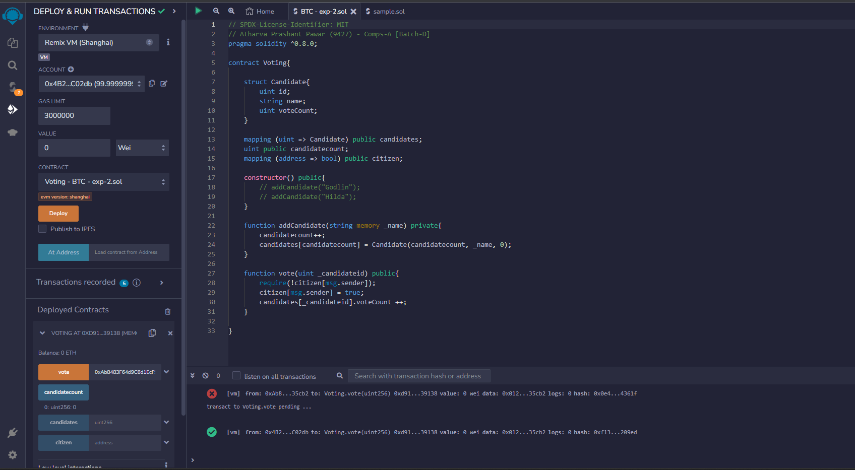

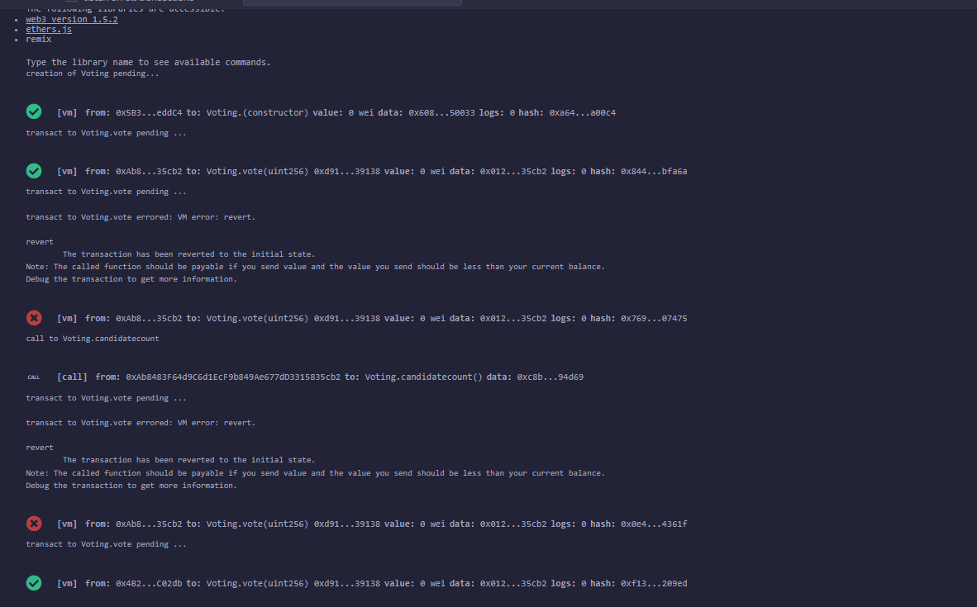

Conclusion: We have successfully created and deployed the smart contract.

Review Questions

Q. 1 What is Remix IDE?
Q. 2 How smart contract is created using Remix IDE?
Q. 3 How the smart contract is deployed using Remix IDE?
Q. 4 What is Gas?
Q. 5 What is account in Remix IDE?
